**Pairwise distance based phylo/trait turnover**

In order to adopt an approach based on solely based on pairwise distances, I have adapted the mean nearest taxon distance (MNTD) metric (Webb et al. 2008) in order to focus solely on turnover. This is because I believe we are interested in drivers of change in community composition and not drivers of richness gradients. I preferred the MNTD metric to the mean pairwise distance (MPD) metric as I wanted a metric that measured the absolute distance between unique species (weighted by their contribution to community turnover). This is achieved by MNTD since all shared species have a nearest taxon distance of zero, therefore lots of shared species result in lots of zeros and therefore reduce the influence of the unique species. For MPD, shared species will have a mean pairwise distance that is influenced by the trait characteristics of all the species in the opposing community and the resulting overall MPD between communities is influenced by within community diversity. I’m not sure this is desirable; I think we want an absolute measure: which communities are the most different? which are most similar? - regardless of within community diversity. So I went for MNTD. This is the formula according to the phylocom package (there seems to be some confusion about the formula but since this is the package that’s always cited I took it straight from here):

$$MNTD= mean(NNab,NNba)$$

Where *NNab* represents all the nearest taxon distances between community *a* and community *b* and *NNab* vice versa. So it is simply the mean of all the nearest taxon distances. My turnover version is:

$$MNTDt=min⁡(mean\left(NNab\right),mean(NNba))$$

Therefore, in keeping with other turnover metrics, only the least diverse community will influence the result. If one community has no unique species then the result will be zero. If the communities have completely different species but the within community diversity is equal (N.B. not species diversity but either phylogenetic or trait diversity, whatever is being measured), then this MNTD turnover metric will be equal to MNTD. I refer to this new turnover metric as MNTD*t*. The nestedness (referred to as MNTD*n*) component is obtained by subtracting MNTD*t* from MNTD*.*

To test the properties for MNTD*t* calculated the metric for the following test communities and traits (as well as MNTDand MNTD*n*):

Table 1. Test community data

|  |  |  |  |  |  |  |  |
| --- | --- | --- | --- | --- | --- | --- | --- |
|  | **Sp_1** | **Sp_2** | **Sp_3** | **Sp_4** | **Sp_5** | **Sp_6** | **Sp_7** |
| **Com A** | 1 | 1 | 1 | 0 | 0 | 0 | 0 |
| **Com B** | 0 | 0 | 0 | 1 | 1 | 1 | 0 |
| **Com C** | 0 | 0 | 0 | 0 | 0 | 0 | 1 |

Table 2. Test trait data for species in communtiy dataset. N.B. Species 1 and 7 have identical traits.

|  |  |  |
| --- | --- | --- |
|  | Traitx | Traity |
| Sp_1 | 1 | 1 |
| Sp_2 | 1 | 2 |
| Sp_3 | 1 | 3 |
| Sp_4 | 2 | 1 |
| Sp_5 | 2 | 2 |
| Sp_6 | 2 | 3 |
| Sp_7 | 1 | 1 |

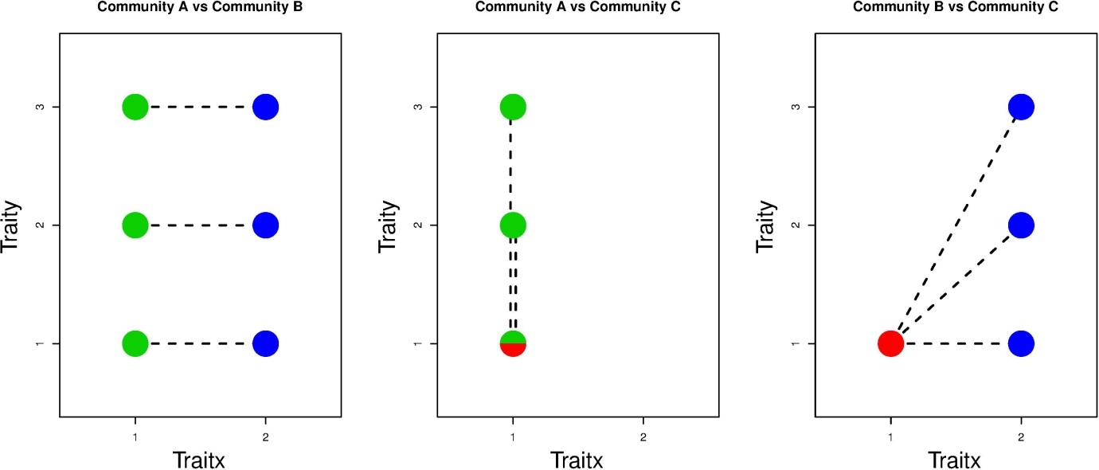

Figure 1. Pairwise between community trait comparisons based on nearest taxon distances.

*MNTD*

|  |  |  |
| --- | --- | --- |
|  | **Com_A** | **Com_B** |
| **Com_B** | mean(1,1,1,1,1,1) = **1** | - |
| **Com_C** | mean(1,2,0,0) = **0.75** | mean(1,1.4,2.2,1) = **1.4** |

*MNTD*t

|  |  |  |
| --- | --- | --- |
|  | **Com_A** | **Com_B** |
| **Com_B** | min(mean(1,1,1),mean(1,1,1)) = **1** | - |
| **Com_C** | min(mean(1,2,0),mean(0)) = **0** | min(mean(1,1.4,2.2),mean(1)) = **1** |

*MNTD*n

|  |  |  |
| --- | --- | --- |
|  | **Com_A** | **Com_B** |
| **Com_B** | 1 – 1 = **0** | **-** |
| **Com_C** | 0.75 – 0 = **0.75** | 1.4 – 1 = **0.4** |

So communities A and B have no identical species and there MNTD*t* = MNTD, whereas community C has no species that are unique from the species in community A and therefore MNTD*t* = 0 and the only difference between the communities is measured by MNTD*n.*